Making Math Meaningful for Autistic Students
Jenny Root, PhD, BCBA
jrroot@fsu.edu
@Dr_Jenny_Root

Big Idea 1 | Math is meaningful when students can generalize skills to solve problems in their everyday lives

- Instruction must support students to progress through all four stages of learning
  - Acquisition
  - Fluency
  - Maintenance
  - Generalization

Big Idea 2 | Curricular focus & perceived ability may cause Autistic students to be victims of low expectations

- The instructional focus for students with developmental disabilities has evolved over the past 50 years
- Changes in policy impacted research and practice
- Research findings have inconsistently been incorporated into policy & practice
- Disability results from a mismatch of environmental demands & individual profile of strengths and needs
- Perceptions of student ability and need is signaled through words, expectations, and supports and influenced by systemic (but sometimes unconscious) ableism

Big Idea 3 | Provide meaningful problem solving tasks
- Benefits of contextualizing math instruction
  - Provide background information
  - Make learning truly “functional”
  - Make instruction meaningful & personally relevant
  - Opportunity to address multiple priorities
- Explicitly connect math to real world context
  - Videos
  - Word problems

Big Idea 4 | Anticipate barriers & proactively support independence

- Independence in problem solving requires both conceptual understanding and procedural accuracy - Simply knowing what to do without when or why is insufficient
- Anticipate potential barriers in:
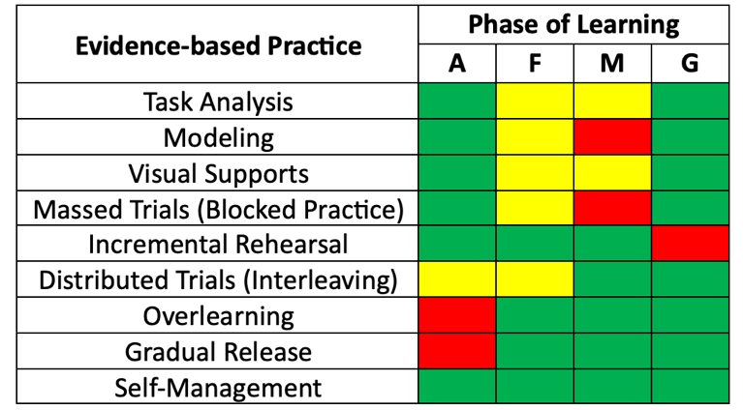
  - Numeracy
  - Literacy
  - Executive functioning
  - Communication
  - Metacognition
  - Gross & fine motor skills
- Align supports to barriers
  - Conceptual Understanding
  - Procedural Accuracy
  - Access
  - Self-determination
  - Executive functions
  - Generalization
- Instructional strategies should align with the phase of learning
- Word problem solving is a natural opportunity to develop and apply social and emotional learning and self-determination

Related Resources

Blog: Teaching Autistic Students to Solve Math Word Problems by Dr. Root in The OARacle https://researchautism.org/oaracle-newsletter/40242-2/

Webinar Recording: The Science of Math: Applying the Instructional Hierarchy with Learners with Autism and Intellectual Disability by Dr. Root for the Centre for Interdisciplinary Research and Collaboration in Autism at the University of British Columbia https://youtu.be/klkOI7nwqaU?si=I5wBJQ68gMdM0Knl

Practitioner Article: Jimenez, B., Root, J., Shurr, J., & Bouck, E. C. (2021). Using the four stages of learning to assess, set goals, and instruct. TEACHING Exceptional Children, Advance online publication: doi: 00400599211054873

Practitioner Article: Root, J. R., Saunders, A., Cox, S. K., Gilley, D., & Clausen, A. (2022). Teaching word problem solving to students with Autism and intellectual disability. TEACHING Exceptional Children, Advance online publication: doi: 00400599221116821

Practitioner Article: Root, J., Saunders, A., Jimenez, B., & Gilley, D. (2023). Essential components for math instruction: Considerations for students with extensive support needs. TEACHING Exceptional Children, 56(1), 34-43.

If you do not have access to TEACHING Exceptional Children, you can access PDFs of the articles at https://bit.ly/3VSUUZR

